**Getting Input from user or Input Statement or Input Function**

**Input Statement – input() Function**

**input()**

This function is used to accept input from keyboard. This function will stop the program flow until the user gives an input and end the input with the return key. Whatever user gives as input, input function converts it into a string. If user enters an integer value still input() function convert it into a string. So, if you need an integer you have to use type conversion. So, if any mathematical calculation is to be performed, we need to convert the input to integer format. For converting the input to integer format python provides us a function called: **int()**

Syntax: input([prompt])

Prompt is a string or message, representing a default message before input. It is optional.

Example:

name = input()

name = input(“Your Name:”)

mobile = input(“Enter your mobile number:”)

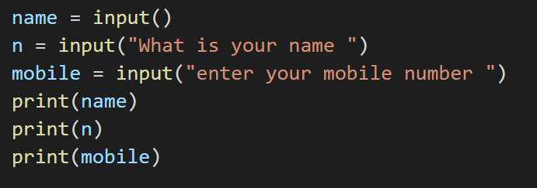

Whatever user gives an input, input function converts it into a string. If user enters an integer value still input() function converts it into a string. So if you need an integer you have to use type conversion.

**Example:**

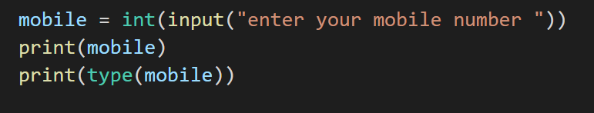

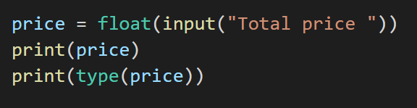

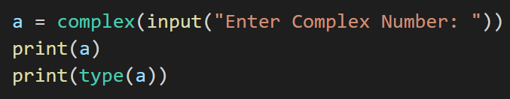

**Example:**

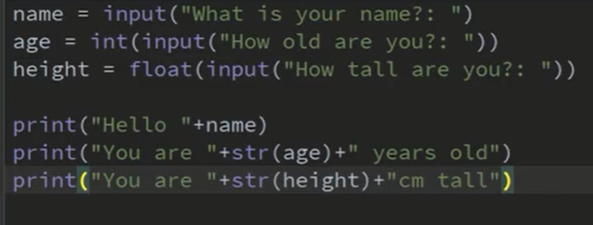

**PYTHON WITHOUT USING INT() FUNCTION**

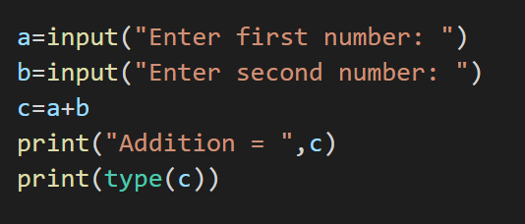

In this case if the value of a and b as given by user is 5 and 6 respectively then the output will be 56. As 5 and 6 will be treated as string and not integer.

**PYTHON USING INT() FUNCTION**

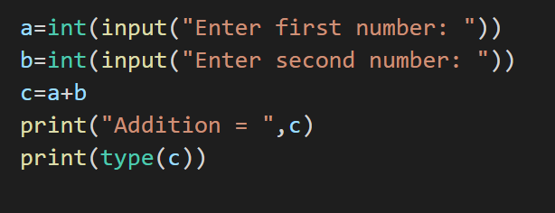

In this case if the value of a and b as given by user is 5 and 6 respectively then the output will be 11 as we have converted the input from string to integer format.

**TYPE CONVERSION IN PYTHON**

The process of converting the value of one data type (integer, string, float, etc.) to another data type is called type conversion.

**Python has two types of type conversion.**

1. **Implicit Type Conversion**

Implicit type conversion of data types in Python, the Python interpreter automatically converts one data type to another without any user involvement. To get a clearer view of the topic see the below examples.

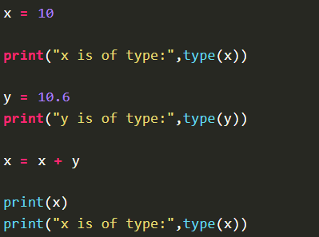

**OUTPUT**

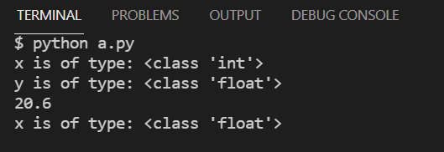

As we can see the type of ‘x’ got automatically changed to the “float” type from the “integer” type. this is a simple case of Implicit type conversion in python.

1. **Explicit Type Conversion**

In Explicit Type Conversion in Python, the data type is manually changed by the user as per their requirement. We use the predefined functions like int(), float(), str(), etc to perform explicit type conversion. This type of conversion is also called typecasting because the user casts (changes) the data type of the objects.

**Addition of string and integer using explicit conversion**

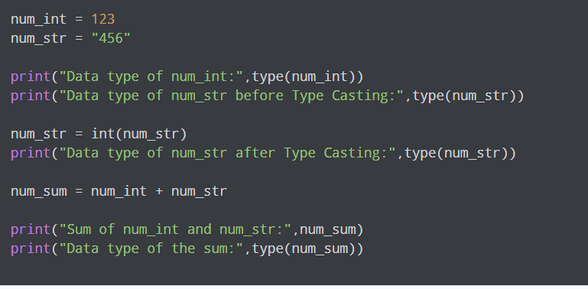

**OUTPUT**

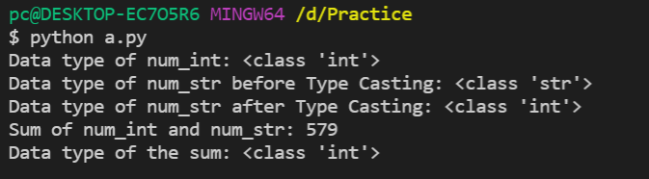

**In the above program,**

* We add num_str and num_int variable.
* We converted num_str from string(higher) to integer(lower) type using int() function to perform the addition.
* After converting num_str to an integer value, Python is able to add these two variables.
* We got the num_sum value and data type to be an integer.